Climate Word Search

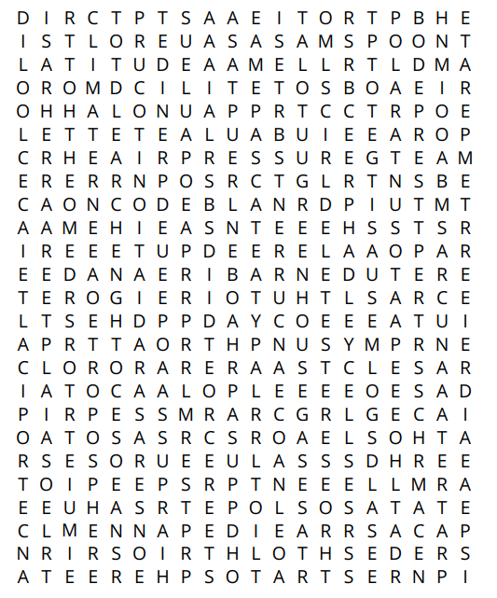

Clues

For each clue, write the word and find it in the word search

|  |  |
| --- | --- |
| Word(s) | Clue |
|  | Layer of the atmosphere where all the weather happens |
|  | Earth’s incoming energy is from solar ________ |
|  | Layer of the atmosphere where the ozone layer is |
|  | Responsible for most weather patterns |
|  | A surface’s ability to reflect light |
|  | The distance a location is from the equator |
|  | Responsible for trapping outgoing energy and reflecting it back to the surface |
|  | Moves a great deal of trapped energy around the surface of Earth |
|  | The general weather conditions in an area over a long period of time |
|  | Convection currents in the atmosphere using the equator as the heat source |
|  | Climate zone with 4 well defined seasons |
|  | Climate zone which gets the least direct sunlight |
|  | Climate zone which receives the most incoming radiation and is therefore the hottest |